OGT Vocabulary Review #1 Name ________________________

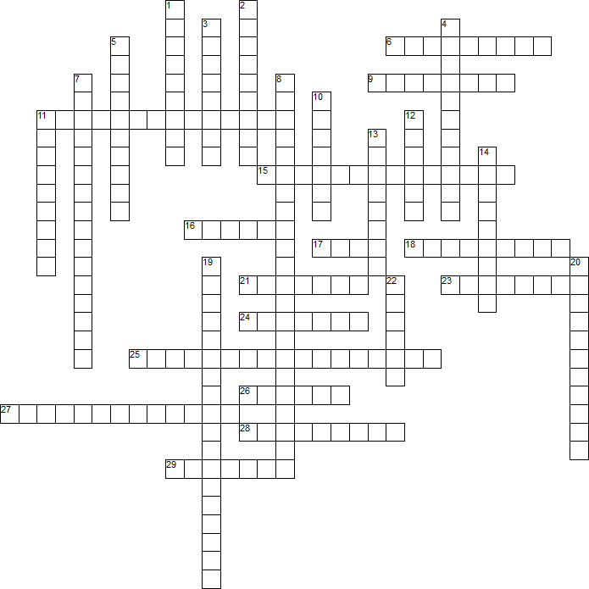

Across
6. the act of spying
9. reliable; believable
11. actions based on prejudice usually based on race, religion, class or sex
15. to take away the right to vote
16. Good shipped out of a country to another country
17. Group (of people, countries, lawmakers, etc) who are united for a common purpose
18. olicy of separation of the races enforced by law
21. to strongly disapprove
23. relates to the production and use of resources, goods and services
24. shared way of living in a society or among a group of people; a way of life
25. refusal to obey laws to try to bring about a change in government policy
26. to make judgments based on very few or no facts; taking sides
27. an 18th century movement that emphasized the use of reason to examine issues
28. tax on goods and services produced and sold within a country
29. refers to the number of people living in a certain area

Down
1. power to govern
2. the final state of social evolution according to Marx, in which the state has withered away and economic goods are distributed according to need.
3. to argue in favor of something
4. protections and privileges given to all U.S. citizens by the Constitution and Bill of rights
5. the leaving of one country to settle in another
7. king or queen has complete control of the government with no regard for the will of the people
8. a constitution creates a democracy and the king or queen is a figurehead with no powers of government
10. to strongly disapprove
11. to overwhelm with problems; destroy
12. relating to people who share a common language, customs and religion
13. money, usually paper money
14. a positive statement or declaration, often without support or reason
19. powerful or major concern usually related to the government's power to intervene or act
20. something gained or taken over
22. A group of emigrants or their descendants who settle in a distant territory but remain subject to or closely associated with the parent country.

