OGT Vocabulary Review #2 Name ___________________________

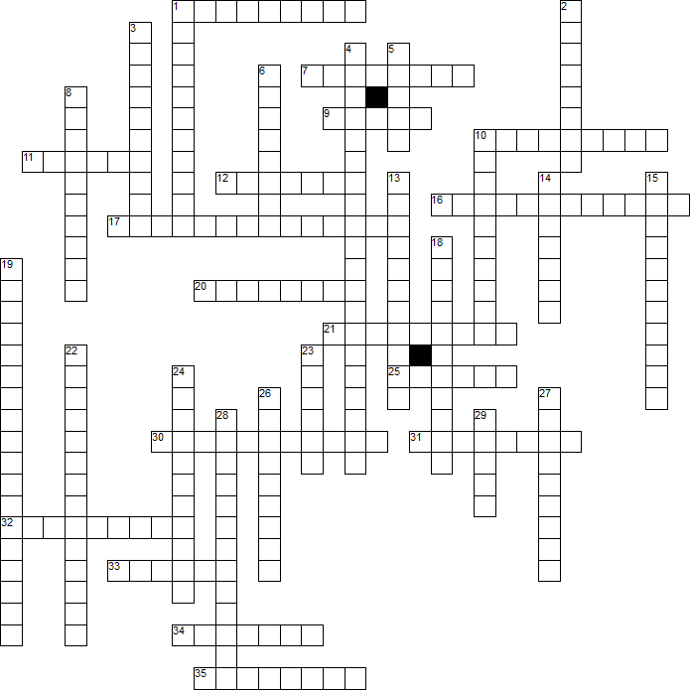

Across
1. to harass, annoy or pick on a person because of the beliefs, religion or race
7. rule by a royal family; a king or queen who inherits their position by birth
9. relating to farming regions; "the country"
10. rising prices
11. Good shipped into a country from another country
12. use of false spoken statements to harm another's reputation
16. belief that the government should allow business to work free from government interference
17. camp for prisoners, usually political prisoners or war time prisoners
20. the right to vote
21. economic system in which the means of production are owned by the government, not the individual
25. One who lives where he was born
30. policy separating people of different races, classes, or ethnic groups, as in schools, housing, etc.
31. impartial; unprejudiced; not taking sides
32. dealing with the affairs of government; refers to boundaries of nations and states
33. an idea or thought supported with facts
34. Taxes on imports or exports
35. dependable; trustworthy

Down
1. a view or outlook on something
2. refers to residential communities surrounding a large city
3. invasion and control of a nation or territory by a foreign power
4. Time period during the 19th century dominated by new
5. Relating to cities
6. to set free
8. the systematic spreading of ideas or beliefs reflecting the views and interests of those advocating a doctrine or cause.
10. Native to a region or country
13. Payments made from one country to another for war damages and war costs
14. to find a solution
15. barrier created by the Soviet Union to prevent communication and trade between Communist eastern Europe and democratic western Europe during the Cold War
18. government rules designed to control behavior and actions of groups, businesses, etc.
19. the distribution of power among the branches of government, giving each branch a particular power
22. Time period during the 19th century dominated attempts to reform and correct the problems of society
23. to prove something false; to deny the accuracy or truth of something
24. extension of one country's power and influence into other areas of the world
26. Movement of people from one area to another
27. type of government based on religious authority; religious leaders are also the political leaders
28. a document, speech, or other sort of evidence written, created or produced during the time under study
29. use of false printed material to harm another person's reputation

