The Federal Reserve
“Gatekeeper of the U.S. Economy”
The Central Bank of the United States

What three things does the Fed do?
1.
2.
3.

How does it does these things?
1.
2.

Why does it does these things?
1.
2.
3.

Directions: Go to http://money.howstuffworks.com/fed.htm to answer the following questions.

- Why is inflation NOT good for our economy?
  - It slows down _______________ _____________.

- How does it do this?
  - Things cost more so people _____________ less.
  - People do less _____________-_______________planning in things like ______________ and investing. They are afraid to spend money because of _____________________.
  - People borrow less because of the additional costs to long-term __________________.

- Inflation summarized:
  - Demand is _______________ and supply of goods _____________.
  - Production ______________ and unemployment ________________.
  - Which leads to ___________________.

- What can the Fed do when a recession hits?
  - A. __________ interest rates.
  - Encourage people to ______________ money and make ________________.

- Why does the Fed need to be careful when lowering interest rates?
  - So ________________ isn’t impact in the ______________ run.

- Name the 2 Fed divisions and what they are responsible for.
  - _____________________
    - Set monetary __________________
    - Manage __________________ money

  - 12 __________________
    - Carry out ______________ of the Board
    - Supervise __________________ ____________
- What are the Fed’s 2 primary goals in managing money?
  - Maintain ______________ ______________
  - Maximum ________________ and _____________

- What does raising and lower the interest rates influence?

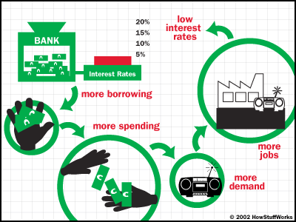

- Complete the following paragraph:
  - When interest rates go DOWN, people spend ____________ because purchasing becomes less expensive. This spending _______________ growth in the economy, but if it happens too _____________ demand will _____________ too fast and supply cannot keep up. Prices then ________________ too quickly which leads to ___________________.

- How is the Fed the “banker’s bank”?
  - Processes and clears a ____________ of all checks which is approximately 20 ______________ checks per year.

- How is the Fed the “government’s bank”?
  - Maintains the ______________________

- What bureaus produce coin and paper currency?
  - Bureau of _________________________________
  - Bureau of _________________________________
- Which 3 ways does the Fed influence the amount of money in circulation and explain each?
  - Reserve ____________________
    - Banks are required to set aside ______________________ usually 3 to ________ percent of their deposits.
  - Discount ___________________
    - The _____________________ _________________ paid by banks to borrow from a reserve bank.
  - Open ______________________
    - Buying and Selling ____________________
    - The SELL to ___________________ the money supply which in turn _____________interest rates.
    - They BUY to ___________________ the money supply which in turn __________________ interest rates.

- Why is the Fed called a “decentralized, central” bank?
  - It is structured to ______________________ government control, but remains accountable to ______________________ and the ____________________.
  - Board is the _______________________ side.
  - Reserve banks are the ____________________ side.

- In examining monetary policy, the FOMC (Federal __________________________________) examines which economic indicators (name the 1st 5)?

Based upon what you have learned from this website, what state (recession, inflation, depression, expansion) is our economy in currently and why do you believe this?
_______________________________________________________________________________________
_______________________________________________________________________________________
_______________________________________________________________________________________
_______________________________________________________________________________________

